SOFT3888 first individual report

Shuwei Zhang 470425437

1. Clear statement of work done

XP roles contribution:

In our project, I’m been assigned the XP roles Software researcher and Doomsayer, for I’m more of a technical-oriented person in our group.

Weekly plan:

Week1:

Intend to do: sign up group contract;

exchange information about each group member’s availability and capabilities;

hold first meeting with client;

set up bitbucket repository and slack channel for project.

Actually done: all of above except bitbucket repository( unable to add tutor)

Week2:

Intend to do: Look into scope statements and begin to produce user stories;

Second meeting with client to exchange ideas about requirement;

Design the application’s functionality and layout;

Fixing bitbucket repository issues;

Research on chatbot platform and voice-text platform.

Set up WIKI page on bitbucket;

Actually done: all of above.

Week3:

Intend to do: confirm requirements with client;

Product the final scope document;

Keep every team member familiar with tools used for development.

Actualy done: all of above.

Week4:

Intend to do: create the draft for week6 group presentation;

Get confirmation on the scope document from client;

Study necessary knowledge for android programming;

Actually done: all of above.

Week5:

Intend to do: prepare for the week6 report and demo;

Create basic UI layout of the app;

Beginning of the group report;

Actually done: all of above.

Week6:

Intend to do: do group presentation and demo on Monday tutorial;

Finish group report and individual report

Actually done: all of above( report in progress)

Reflections:

Overall, our group’s progress is hindered by the lack of knowledge about necessary components we identified for this project (Android programming, chatbot platform, text-voice recognition platform). However, everybody in the group is doing hard work to keep up with the project. Extensive technical research has been went through by me and Harry and therefore we will be able to help our teammates to quickly get familiar with the tools and technologies we are using in the project.

During first week, due to the fact that our group was formed through random allocation, we had our week 0 progress fell behind, so only until week 1 we were able to meet our team members. This dragged our progress a bit, but not much.

Through negotiation with our client thoroughly, our team were able to quickly produce a project scope document that is well accepted by our client. 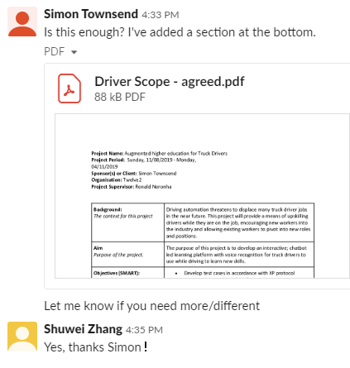

Generally, our group is progressing stably, considering the fact that we had huge knowledge gaps. Thanks to the XP development methodology, we are able to confirm the requirements and prototype our product fast to leave more time for studying and researching, through extensive communication with our client.

1. Quality of technical work done

On the technical side of the project, due to the fact that nobody in our group is familiar with android development and chatbot & voice-text recognition platform, as the software researcher in our group, I need to extensively do research about these contexts and help my other group members to catch up if they needs. (help them set up system, etc)



Through the learning of android coding on google website:

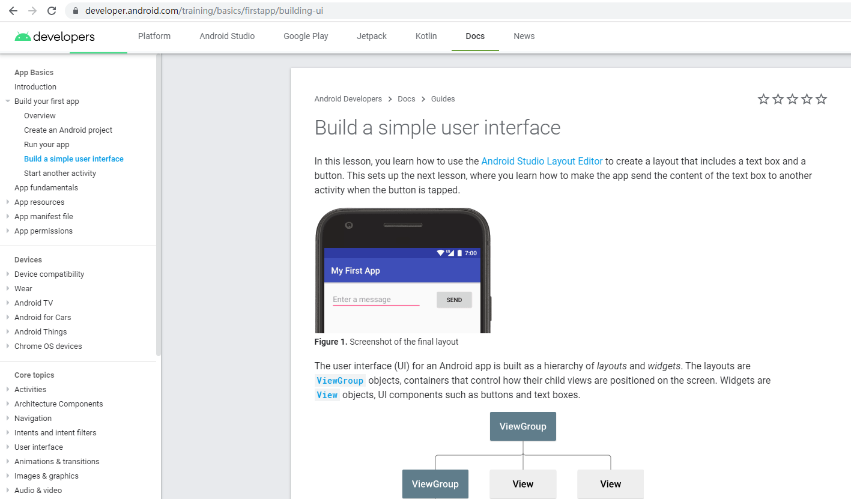

Researching website:

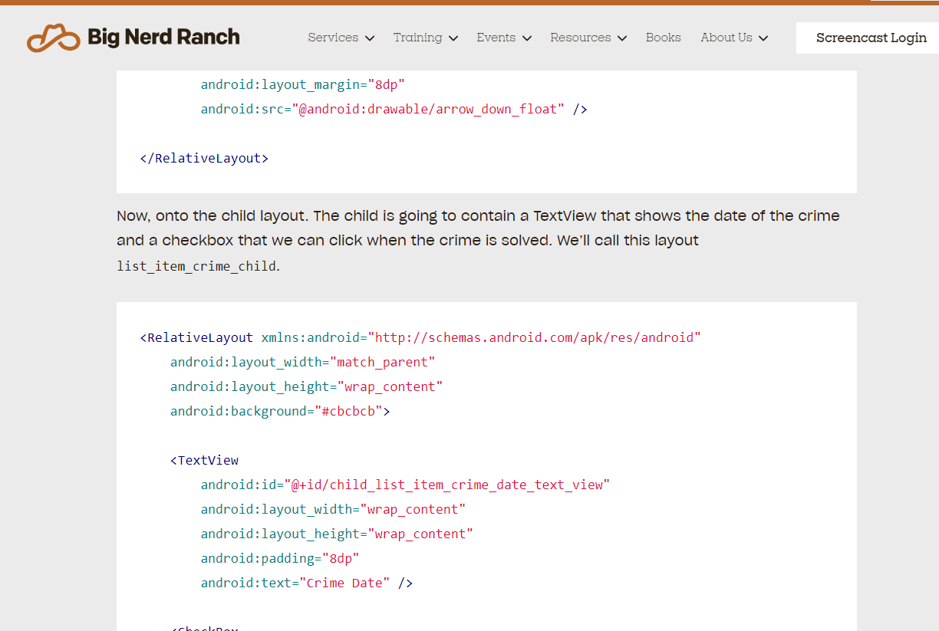

And github:

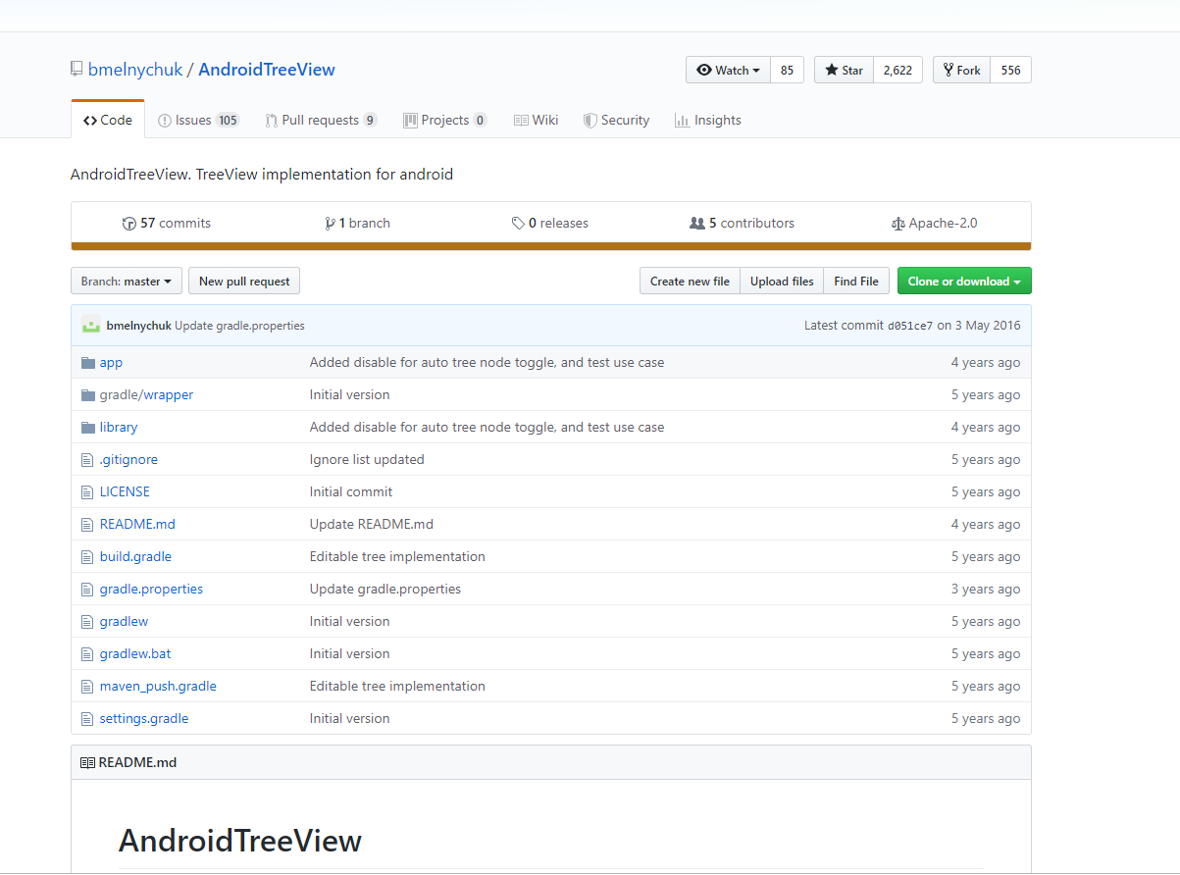, I was able to quickly learn the fundamental for android programming. Therefore, I was able to create a basic UI for both start of our project and for the week6 demo. Both clients and my team are confortable with that:

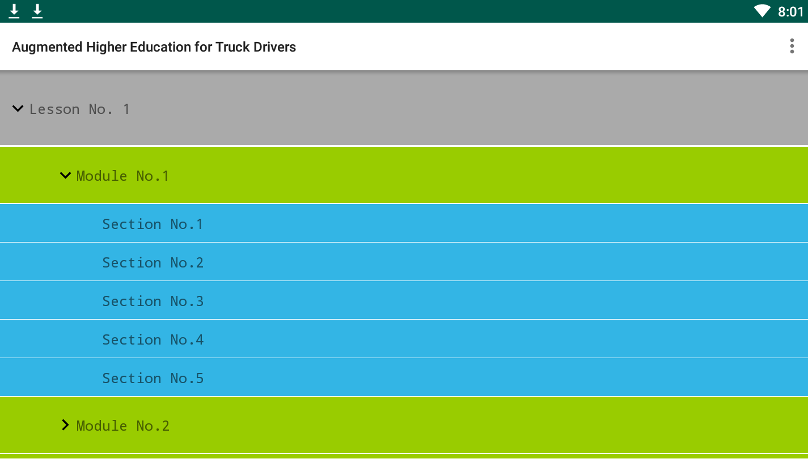

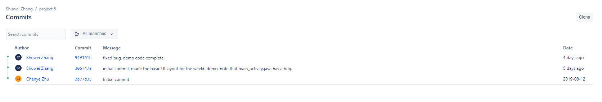

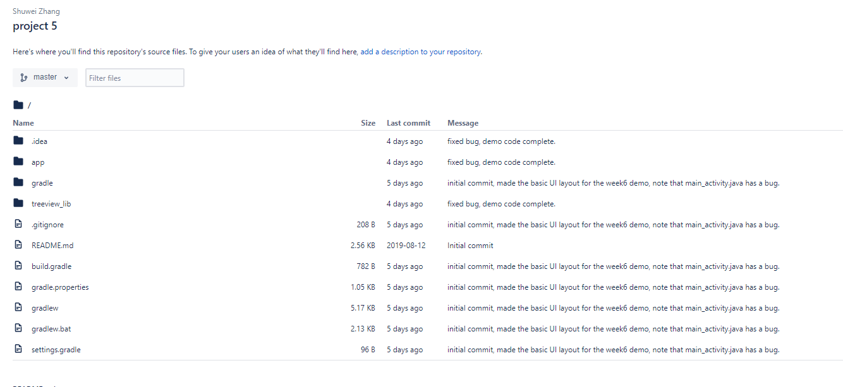

1. Other contribution to group processes

Group activity:

As the manager for first week, I was responsible to manage the team. Therefore, I created the slack channel, and tried to add everyone in it. Also, when Harry encountered problems on setting bitbucket repository, I was able to help him, also subscribing to our slack channel.

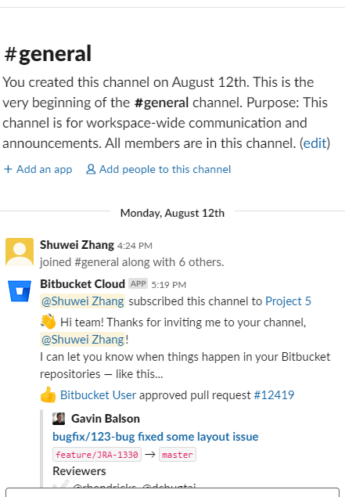

Later, I found that the bitbucket cloud is not working properly, so I used an external app called ‘Zapier’ to link the bitbucket repository to our channel.

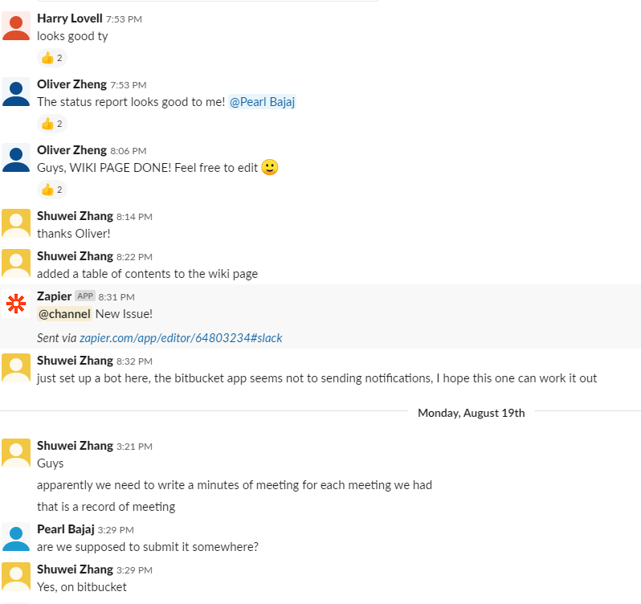

Also, through the study of #Markdown language at <https://confluence.atlassian.com/bitbucketserver/markdown-syntax-guide-776639995.html>

And <https://bitbucket.org/tutorials/markdowndemo/src/master/>,

I was able to create the stub of table of contents to the wiki page, and therefore teaching rest members of our group how to do that.

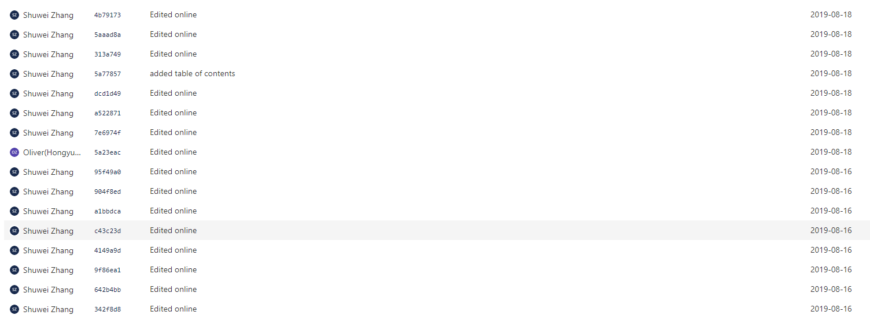

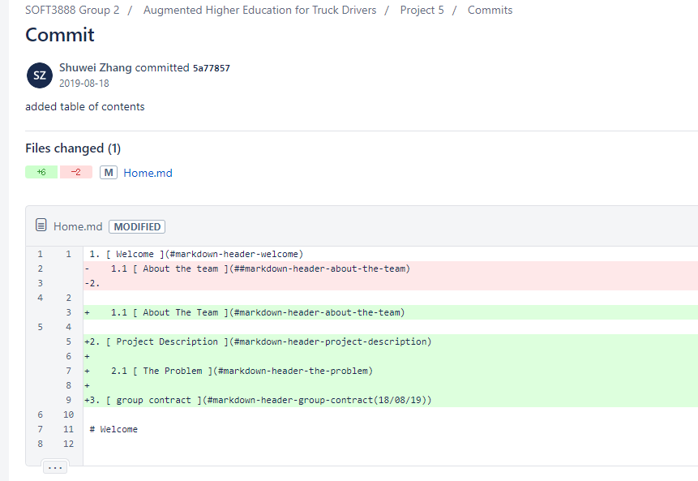 (old repo)

On the second week, an unexpected issue happened: we were unable to add our tutor in our group repository. Therefore, I created a new repository, and transferred our wiki to the new repository, and also subscribing to the new repository on slack.

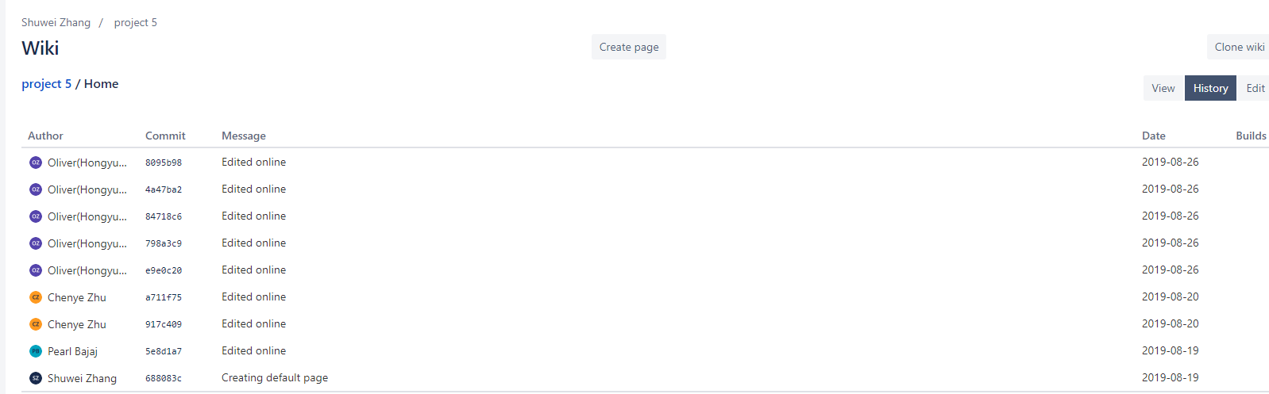

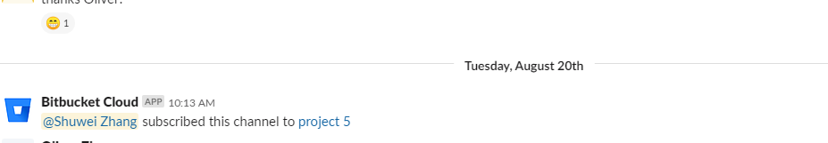

Later, we used slack for communicating within our groups and with client.

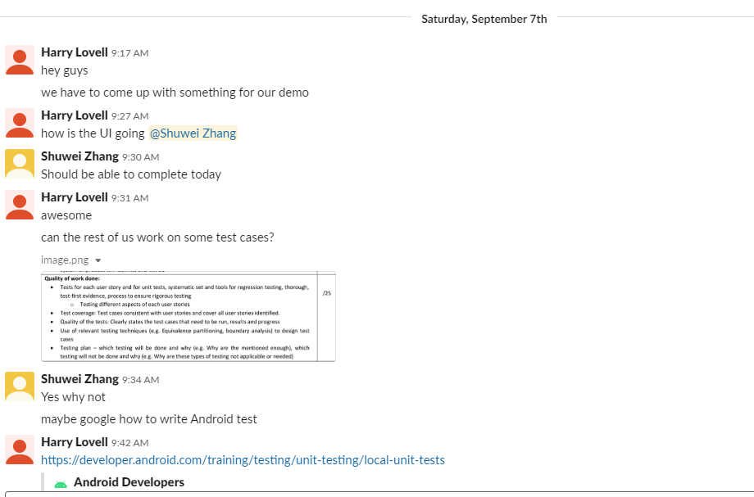

To communicate with client in the best way, I attended every single client meeting except in week6 which we overlooked the message and missed it.

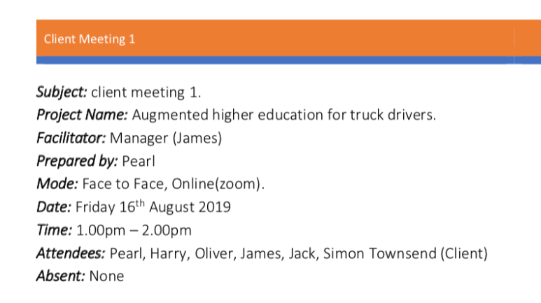

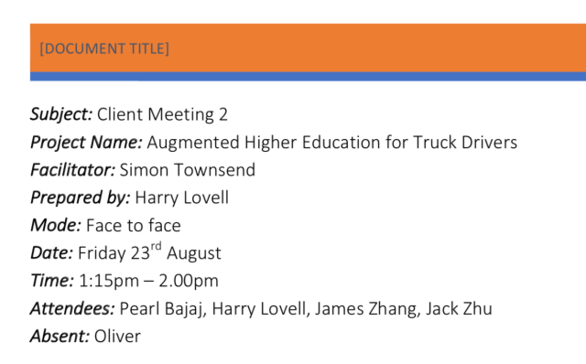

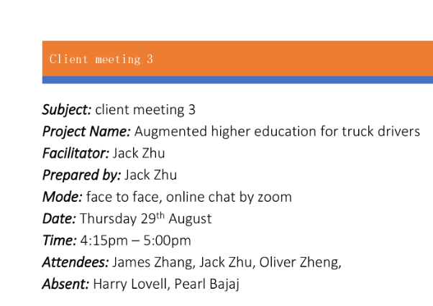

I also presented the demo of our project to our client via slack.

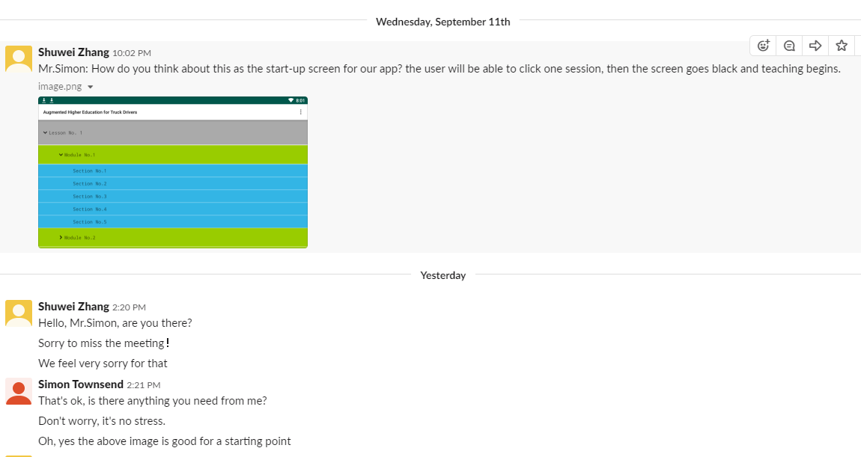

To help with project tracking, I have done recording the client meeting minutes 3 and status report 4 for the group.

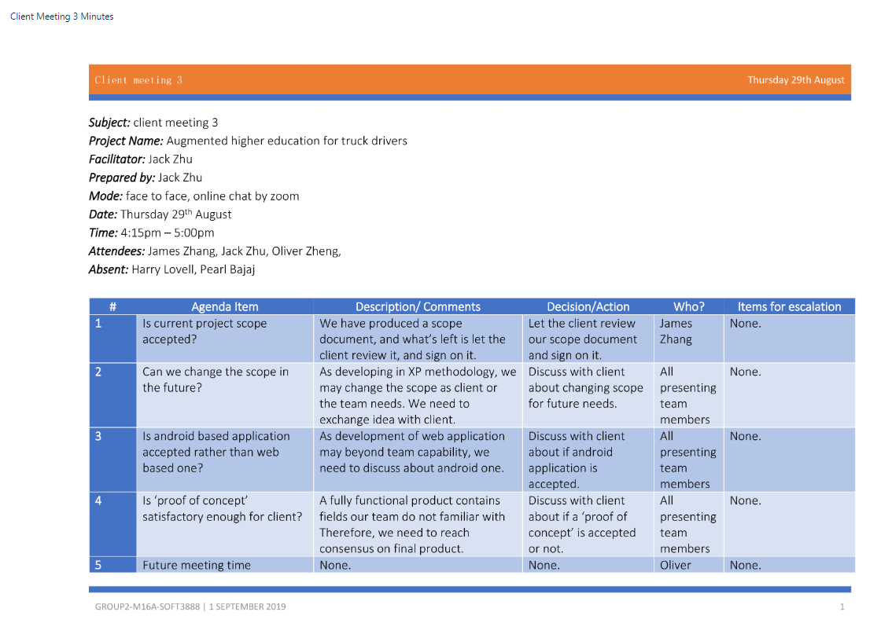

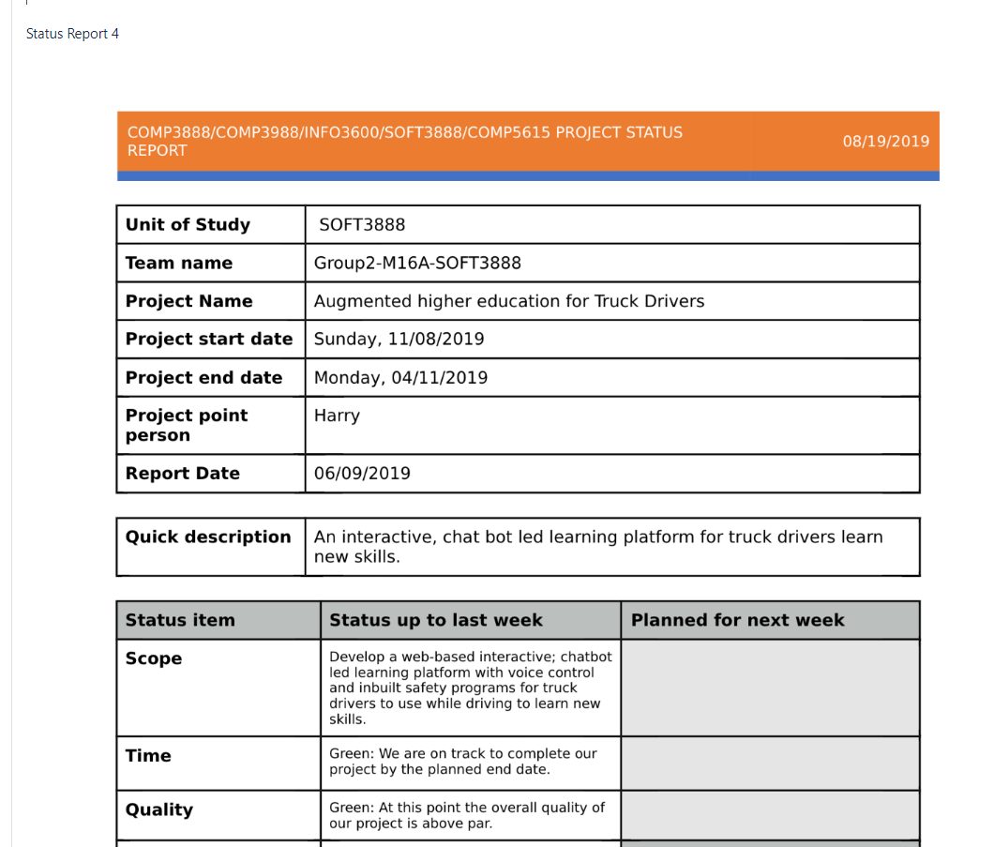

Issues:

The issue management system is essential for teamworking in an agile development environment. The team can effectively find their aim and improving a part of project by creating issue and assigning them, eventually resolving them.

In our project, the issues are managed through bitbucket:

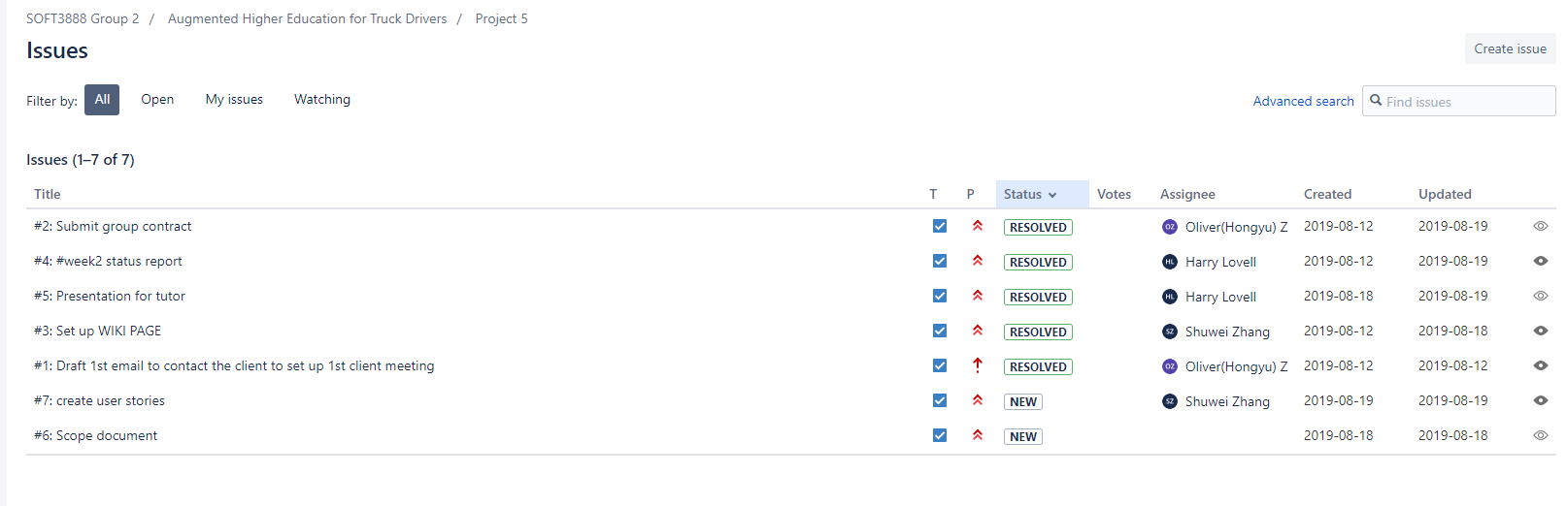(old repo)

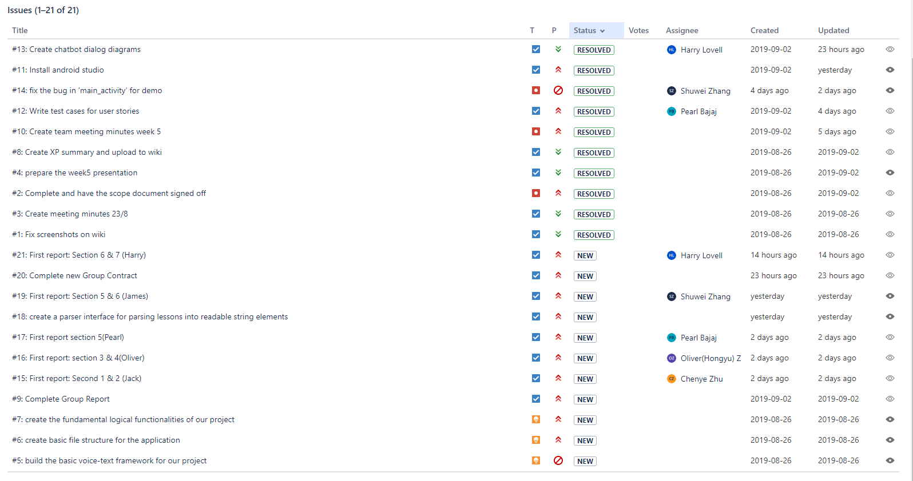

The issues are categorised into different types and urgencies. Each group member can create an issue as long as he/she wants to, and the rest group member can see it and finish it, then mark the issue as resolved. The issue can also be assigned to a specific group member to let him/her focus on it.

We used the issue management system to set our goals and complete them effectively.